## - Lesson slides-- Lesson 9 Elevator pitch

## Lesson 8 - Lesson slides

### notes

|  |  |  |
| --- | --- | --- |
| Keynote speech  Business conference | /ˈkiːnəʊt/ | main |
| Theme  Topic / titles / subject | /θiːm/ | his letters were always on the theme of love  the subject matter of a conversation or discussion  Theme park  Main theme |
| Motivate  Inspires | /ˈməʊtɪveɪt/  /ɪnˈspaɪə(r)/ | Music can motivate  Keep daring to motivate  Inspires us each day  Develops and inspires others |
| celebrities | /səˈlebrətiz/ | Stories about celebrities  Stories about celebrities |

|  |  |  |
| --- | --- | --- |
| Create an **engaging** workplace | /ɪnˈɡeɪdʒɪŋ/ | attracting or delighting |
| Summarize  Sum up, outline  concluding | /ˈsʌməraɪz/ | give a summary (of);  concluding :occurring at or forming an end or termination |
| strategies | /ˈstrætədʒiz/ | an elaborate/complex and systematic plan of action  response strategies  instructional strategies [marketing strategies](javascript:;) |

### Lessons

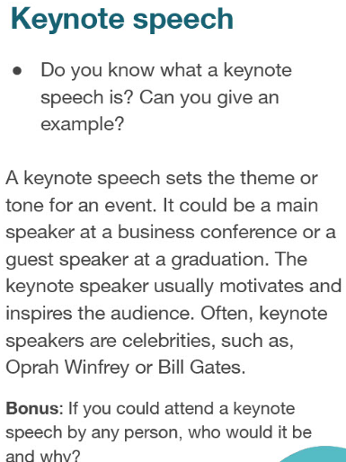

|  |  |  |
| --- | --- | --- |
| Create an **engaging** workplace | /ɪnˈɡeɪdʒɪŋ/ | attracting or delighting |
| Summarize  Sum up, outline  concluding | /ˈsʌməraɪz/ | give a summary (of);  concluding :occurring at or forming an end or termination |
| strategies | /ˈstrætədʒiz/ | an elaborate/complex and systematic plan of action  response strategies  instructional strategies [marketing strategies](javascript:;) |

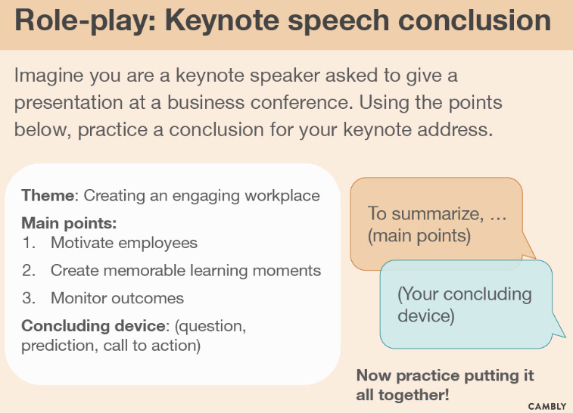 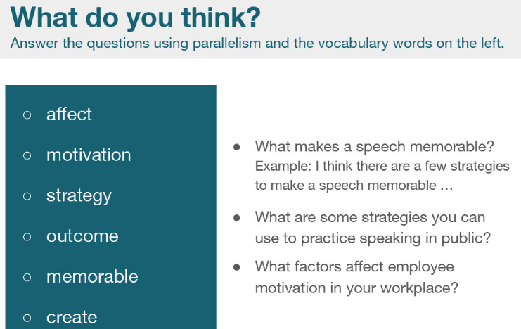 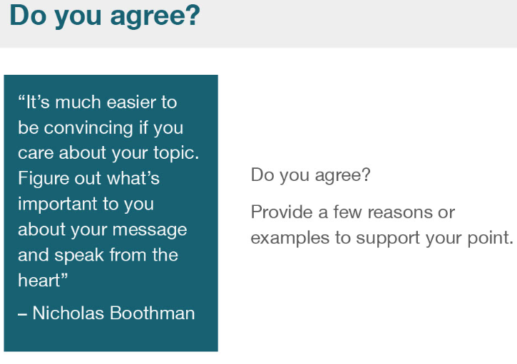

## Lesson 9 Elevator pitch

### Notes

|  |  |  |
| --- | --- | --- |
| My tutor will find something for me to do soon! |  | ...more efficiently and more balanced |
| operational research | I would like to be relaxed...  ...in order to write academic papers more efficiently |  |
| I would love the opportunity to study under you in Rome. |  | I would like/love  ~~I would want~~ |
| Etc: etcetera |  |  |

(1 Introduction) Hello, my name is Frank and I'm a postgraduate student in transport engineering. My research focuses on using parallel technology to solve traffic problems.

(2 Goal)My tool means thousands of people can use a taxi ride app (like Uber) at the same time without crashing the system. This saves people time and makes the app more efficient.

(3 Unique selling point)This can be expanded to calculate tens of thousands of rides and can be applied to the world's largest cities.

(4 Call to action) Would you be interested... in taking my details .....in supporting me with funding ....in helping me with my research?

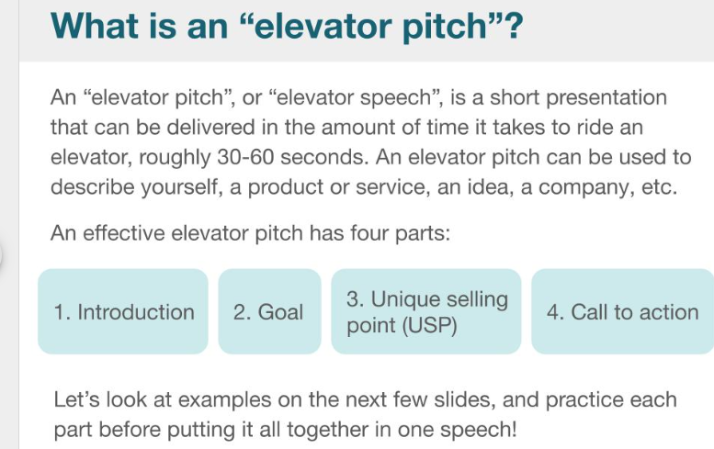

### Lesson

**11:35 PM**

Operate research

**11:33 PM**

Stuart E

My tutor will find something for me to do soon!

Use short time (30 seconds) to sell your product let the customer be convinced.

